Sharina Richard
Biotechnology
Dr. Qin
October 30, 2007
Lab # 9

Building Phylogenetic Trees in MEGA

1.3
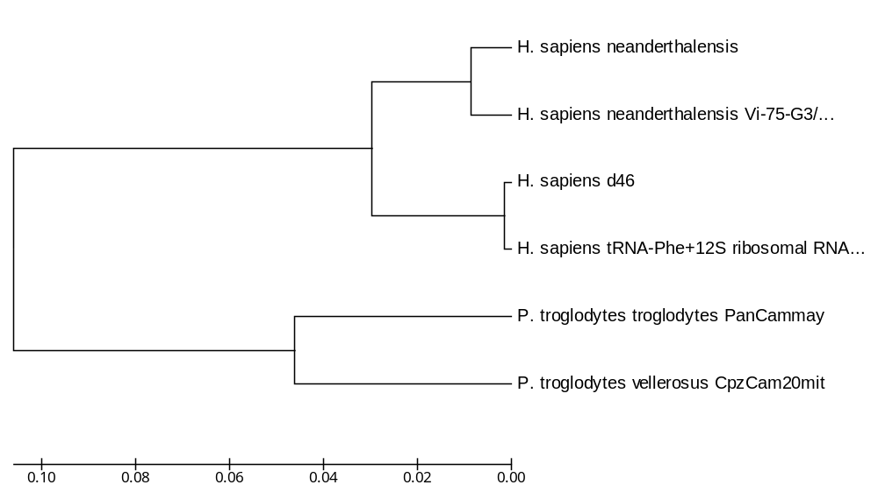

2.2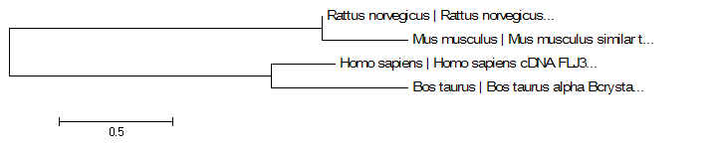

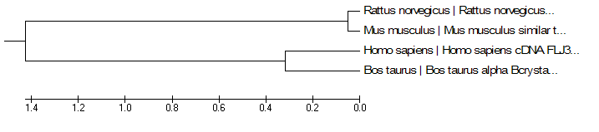

The evolutionary history was inferred using the UPGMA method. The optimal tree with the sum of branch length = 3.22089578 is shown. The tree is drawn to scale, with branch lengths in the same units as those of the evolutionary distances used to infer the phylogenetic tree. The evolutionary distances were computed using the Nei-Gojobori method and are in the units of the number of nonsynonymous substitutions per nonsynonymous site. All positions containing gaps and missing data were eliminated from the dataset (Complete deletion option). There were a total of 194 positions in the final dataset. Phylogenetic analyses were conducted in MEGA4.

2.3